****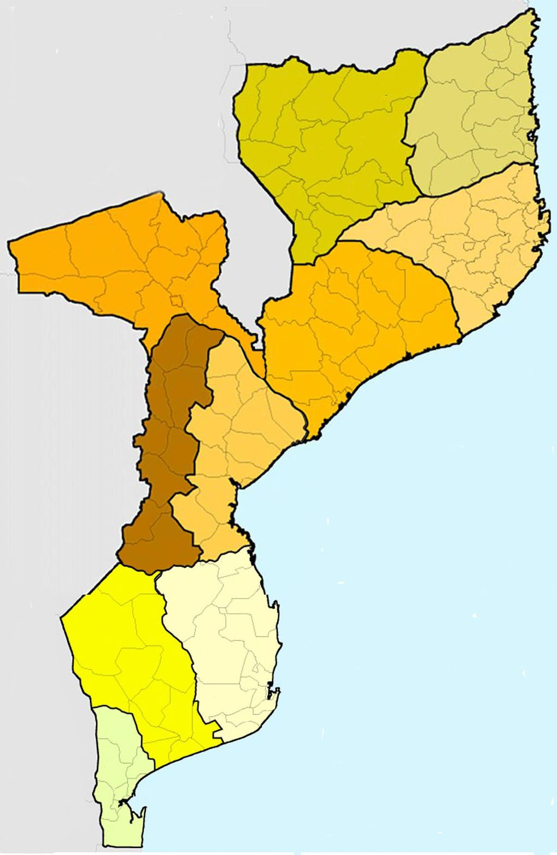R

**INHAMBANE**

**ADPP, AIPDC, AMODEFA, AMVIRO, AKKV, ATTV, CCS, CCM, Centro de Esperança (IM), COALIZÃO, ECOSIDA, FDC, KHURULA, KUYAKANA, LAMBDA, LIWONINGO, MAHLAHLE, MATRAM, MONASO, N’WETI, POSITIVO MOÇ, Rede Pastoral Homoine, RP Inharime, RECAC, RCCHS, TSINELA, UTOMI, VICODEMO**

**(MALARIA CONSORTIUM)**

**CIDADE de MAPUTO**

**ACTIVACO-TB. ADPP, AHITIPALUXENE, AMDEC, AMICUMO, AMIMO, AMPR, AMODEFA, AMORA, ANAVIL, ANEMO, ARISO, ASSOC, ASSODECO, ATA-TPS, AVVI, AYMA AUNUE, CASA ROSA, CCS, CIP, COALIZÃO, CMA, CVM, ECOSIDA, ESTAMOS, FAMOD, Fundação Shiva, HANYANYA, HIXIKANWE, HKURULA, HOCOSIDA, Igreja Anglicana, KHANIMAMBO,** **KENGUELEKEZE, KHENSANE, KINDLIMUKA, KULIMA, KUPFUNANA, KUTENGA, KUYAKANA, LAMU, LUARTE, MAKUMBI YA SAUDE, MONASO, MD GACHENE, MOPCA, MULEIDE, NAMATI, NDAGWINI CAF, NIWANENE, NOS POR EXEMPLO, PACO, PARTEIRAS DM, PFUKA U HANYA, PLASOC-M, RAVIM, REDE HOPEM, REENCONTRO, REJUSIDA, RENSIDA, REVIDA, TINENHA, UNGANA, UNIDOS, VIDA SEM CANCER, VV INFULENE, YINGUISSETA,**

**(CSE – DREAM + AHF)**

**PROVINCIA de MAPUTO**

**ACIDECO, ACODEMU, ACTIVACO-TB, ADPP, AJPJ, AJUCOM, AMODEFA, AMDEC, AMUCHEFA, ASSEDUCO, AVANTE MULHER, CARITAS, CMA, CONFHIC, CCS, ENDELEZA, FUNDAÇÃO ARIEL, ECOSIDA, FDC, FAM, GAD, GTO, ICRH, KENGUELEKEZE KINDLIMUKA, KUFUNANA, KUYAKANA, LAMBDA, MATRAM, MONASO, N´WETI, REJUSIDA, SANTAC, TIYANE VAVASSATI, UNGAGODOLI**

**(PATH)**

**MANICA**

**ACAMO, ACACON**

**ADPP, AEXEMO, ANDA, AMODEFA**

**BATSIRAI NHERERA**

**CA BARUE**

**ECOSIDA, FAMOD**

**FDC**

**GIRL CHILD RIGHT**

**JOSSOAL, KUBATANA KUBATSIRANA**

**KULIMA, KUYAKANA, KUZVIPIRA, LAMBDA**

**MAGARIRO**

**MONASO, NANDA**

**OMES, PLASOC**

**RENSIDA,**

**RUDO KUBATANA**

**SHINGUIRIRAI**

**(?)**

**NIASSA**

**ADPP, AMODEFA, ARV, CIP-CESC-NWETI (MAIS VIDA), CCM, DIOCESE ANGLICANA, ESTAMOS, FAISCA, FDC, FONAGNI, FUNDAÇÃO ARIEL, HANKONI, KALIDWE, KAMULANE, KUIMUKA, KUYAKANA, LAMBDA, MONASO, N’WETI, OLAKA, PROGRESSO, UNIDOS**

**(UNITED PURPOSE)**

**CABO DELGADO**

**ACDMontepuez**

**ADICAD, ADPP, AJODEMO**

**AKHILI, AMODEFA**

**CVM, COLIZAO JM**

**DESAFIO JOVEM**

**ECOSIDA, FDC**

**FUNDAÇÃO ARIEL**

**KAERIA**

**KHARIBU-HPP, KUYAKANA,**

**LAMBDA, MAWAZE**

**MONASO, MULEIDE**

**NIKALIHANE, N’WETI**

**PSCD Metuge**

**PROGRESSO**

**SEPEQUEYANGO**

**WIWANANE**

**(PATHFINDER)**

**ZAMBÉZIA**

**ACCEVE, ADPP, AMME, AMODEFA**

**ASSODELI, CARITAS, COALIZÃO**

**ECOSIDA, ESPANOR, FDC, FONGZA**

**Igreja Reformada, KUYAKANA, LAMBDA, MONASO**

**NAFEZA, NANA, N’WETI, REJUSIDA, UNIDOS**

**(FHI360)**

**NAMPULA**

**ADPP, AEXEMAC**

**AFDC, AJN**

**AMASI, AMODEFA**

**AMORA, ASAS**

**AVEDOS, CCS,**

**ECOSIDA**

**EKUMI, FDC**

**Igreja Luterana**

**KUYAKANA**

**LAMBDA**

**MONASO**

**NIVENYEE**

**NIWANANE**

**N’WETI**

**OPHAVELA**

**OVARELANA**

**RECAC, UATAF**

**WATANA**

**SOFALA**

**ACAMO, ADEL, ADPP, AJULSIDA, AMDEC**

**ASCUDI/Marromeu, CCM, COALIZÃO, COMUSANAS, ECOSIDA ESBAMANA, FDC, FOPROSA, Igreja Anglicana, Igreja Baptista, IND/Marromeu**

**KUDPEZANA, KULIMA,KUMUSSANA**

**KUPHEDZANA/Buzi, KUYAKANA, LAMBDA, MONASO MULEIDE, N’WETI, ORAM/Nhamatanda, PALO, PFUKA U HANYA, PNDH, Renascer em Cristo, VIDEC, WIWANANA**

**(CUAMM, MSF PATHFINDER)**

**PONTO FOCAL SAUDE ONG-DPS**

**GAZA**

**ACAMO, ACLLN**

**ACOSADE, ACTIVA**

**AESP, ADPP, AMJ**

**AJUSIDA, APAPURG**

**AMIMO, AMODEFA**

**AREPACHO, CEP, CVM**

**ECOSIDA, ENDELEZA, ESBAMANA**

**FDC, FONGA, GAD**

**Igreja Baptista, KUYAKANA, LAMBDA, MATRAM, MONASO,** **MOPCA, N´WETI, PFUNEKA, REENCONTRO**

**TEBA, THEMBALETHU**

**RECAC, RCCHS, REJUSIDA, RUVUMBANA**

**UDEBA, UTOMI, VANGANO VA INFULENE,**

**WIWANANA**

**(JH PIEGO + EGPAF)**

**TETE**

**ACRIS, ADELT, ADEMUCHA, ADPP, ADR, AGT, AMODEFA, APITE, ASUFA, ATENDA, AZINJI, AZEMAP, Caritas Diocesanas, CHIEMBEKEDZO, CHIGWIRIZANO, ECOSIDA, FDC, ICRH-M,**

**Igreja Anglicana, KUPULUMUSANA**

**KUTHANDIZANA-KUCHIRA, KUTCHESSA, KUYAKANA, LAMBDA, MONASO, RECAC, RENSIDA, TIWASSAMALE**

**(JHPIEGO)**

**NAIMA+© 2020**

**Presença das OSC do sector saúde em Moçambique**